Web Application Using Node-Red

Team ID: P N T 2 0 2 2 T M I D 38167

Project Name: IoT Enabled Smart Farming Application

Flow 1

Date:19 November 2022

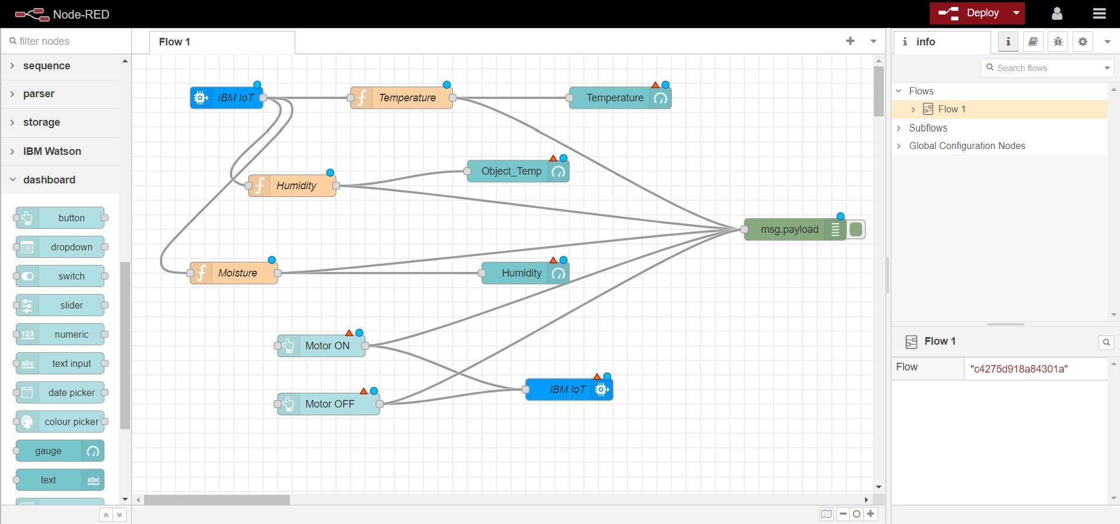

Flow 2:

